EYFS Reading Games To Enjoy With Your Child

Letter Sound scavenger Hunt!

A fun collecting game

What you need
- Letter cards (you can make your own if you don’t have any)
- Basket or any type of container

How to play

- Choose a card and together read out the letter sound – e.g. ‘b’ as in bat.
- Pick up your basket and go on a sound hunt around the house or garden and collect as many things as you can that start with your sound. If you find something that it’s better not to pick up (like a bee) or is too big, draw a picture of it instead!
Talk about the wonderful things you have found. Can you ‘paint a picture’ with your words?

Find the letter
based on ‘Hunt the Thimble’
What you need

- Two sets of letter cards (can be handmade)

How to play
- Player 1 selects a letter card from the first set and hides it somewhere in the room.
- Player 2 finds the matching card from the second set and together both players say the sound.
- Think of and say a few words that start with this sound, e.g. f for frog.*
- Player 1 gives the second card to Player 2 and asks them to hunt for where card 1 is hidden.
Player 1 can give clues to helps the second player e.g. close, closer, very close, far away, etc. to help them locate the card.
Example: You’re rather cold, why not move a little towards the… and you’re so close you’re almost touching it, etc. (This helps to keep the child engaged with the activity.)
*Makes the sound meaningful.
Nursery Rhyme Walk!
Out and about fun!
Nursery rhyme books encourage early years reading due to their musicality and structure. Reciting nursery rhymes helps to promote intonation skills and pace as well as being lots of fun!

What you need
- A location of your choice
- A nursery rhyme book (or just your own knowledge of nursery rhymes)

How to play

- Choose a place to take a walk in, such as the local park.
- Take it in turns to choose something you see that reminds you of a nursery rhyme.
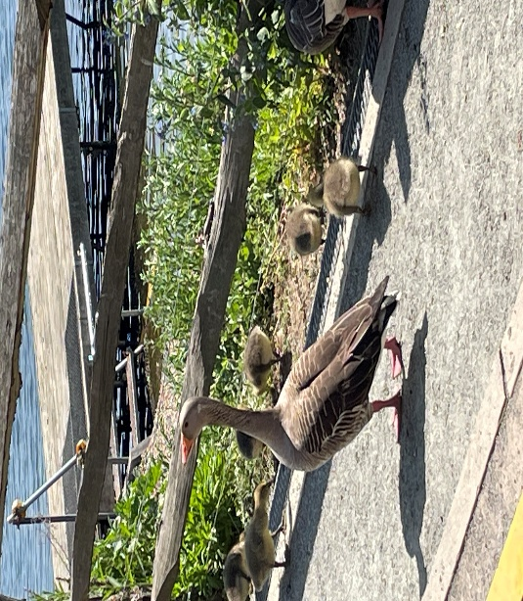
- Point to what you’ve chosen and sing or say the rhyme.
Opportunities to engage in sharing rhymes are all around us as shown by the photo of this mother goose with her goslings, which matches the old rhyme: Goosey Goosey Gander!

Dramarama!

Acting Fun!

Acting out stories encourage memory, intonation, and empathy skills.

Share a favourite story and together act it out (or your favourite part).

Can you:
- Play different parts?
- Give your characters their own voices?
- Give the story different endings?
- Make your own props?
Jigsaws as books!
Parents, did you know that jigsaw puzzles are great for developing pre-reading and early reading skills? Pieces fit together to form a picture in the same way that letters fit together to form words, words to form sentences, sentences to form paragraphs, paragraphs to form pages, and pages to … FORM BOOKS!
Jigsaw puzzles are also a brilliant way to promote:
- problem solving/logical thinking skills
- concentration
- hand-eye coordination
Jigsaws come in many shapes and forms (including 3D). Building a jigsaw puzzle collection doesn’t have to be expensive; there are loads of fabulous ones to be found in your local charity shop.

Make Your Own Jigsaw!

What you need
- paper
- card (can be from cereal boxes, etc.)
- crayons
- pencil
- ruler
- scissors
- glue

How to make your jigsaw
- Draw a picture on the paper and colour it in.
- Glue the picture to a piece of card.
- Cut the card to fit.
- Divide the picture into squares or rectangles*
- Cut out the squares/rectangles

You can now mix them up and have fun putting the picture back together!
*Depending on your child’s age, you might wish to start with two-piece jigsaws (you could make a set) and then progress into making jigsaws with more pieces.

